eNews

January 2020 Issue

TEMPO Racine’s Monthly Luncheon February 13, 2020

Networking Lunch with the African American Chamber of Commerce
Location: 2 Christopher Columbus Causeway, Racine, WI 53403
Time: 11:30 a.m.
Members and Guests can RSVP here.
New Sponsors
We are happy to announce we have recently secured new sponsors: Mrs. Myers Reading Room, Playroom, Inc and Racine Community Foundation.

transitioning
TEMPO Racine is changing its website manager to Wild Apricot. The new site is going live February 1st. Members will receive email links to set up their username and password. As we are setting up the website, you might receive several emails as we test the email functions. We apologize for the inconvenience in advance. However, please do not forget to register for February’s event. We will make that invite clear in the email’s subject line. If you have any questions or concerns, feel free to email Toni or Andrea at info.temporacine@gmail.com. Thank you for your continued support and patience!

Did you know?
We had an entertaining and informative “getting to know you” session at our January monthly meeting.
We learned how many of us enjoys singing in the car, who are members of a motorcycle club, who are happy with the path they

"A coach just has a different perspective. Still to this day, the best have coaches because the coach can see what you can't see because you're in the forest, they're outside of it."
Anthony Robbins,
Author, philanthropist and life coach

are on or are looking for change. Who are mentors and are being mentored. And finally, an honest admission that we all still can get overwhelmed, lost, or stuck.
Interested in mentoring or being a mentor, contact Jackie Zach, the Chair of our Mentoring Committee

ramac and TEMPO Racine: Leadercast Events at UW-Parkside
Scheduled for 2/21, 2/28 and 3/6
Location: UW-Parkside 900 Wood Rd,
Kenosha, WI 53144
Eventbrite Registration Link:
Leadercast Women 2020 Discover the Power of Courage

TEMPO Racine’s Monthly Luncheon March 12, 2020

Location: Racine Country Club
Time: 11:30 a.m.
Members and guests registration coming soon

Spotlight on Sports with Peter Feigin, President of

the Milwaukee Bucks and Fiserv Forum

More Than a Game: How Bucks Basketball Has Ignited Global Markets,
Digital Gaming, and Local Community Development

Date: Feb 18, 2020
Time: 7:00 p.m.
Location: Carthage College, Clausen Center
Free and open to the public. Please register in advance.

Link to website and registration page: https://www.carthage.edu/news/spotlight-on-sports/

Carthage College Trauma and Wellness conference 2020:

A Vision for Community Engagement and Healing

Dates: Feb 25-26, 2020
Location: Carthage College, Todd Wehr Center
Free and open to the public. Registration is required.

Co-sponsored by Carthage College and the Milwaukee Journal Sentinel, the conference will explore the many, intersecting facets of this topic in the context of southeastern Wisconsin. Keynote addresses will be delivered by Timothy Grove, senior consultant at SaintA, and by Ramel Kweku Akyirefi Smith, president and CEO of Blaquesmith Psychological Consultative Services, LLC.

Link to the website and registration page:
https://www.carthage.edu/news/trauma-and-wellness-conference-2020/

The Stowell Team is excited to invite you to our Grand Opening Event being held at Uncorkt,

in celebration of our newest office in Racine!

Stowell Associates - Racine Office
245 Main Street, Suite 104
Racine, WI, 53403
P: 262-880-5864
Complementary drinks and appetizers will be served at Uncorkt
(across the street from our Racine office) beginning at 4:00pm.
We are now actively serving both Racine and Kenosha communities with our
Care Management and Caregiving Services.
For immediate inquiries, or questions regarding the event please contact:
Brooke Forseth
Intake Coordinator
414-635-1896
bforseth@stowellassociates.com
Kindly RSVP through our e-vite link at http://evite.me/pvRFNBPxNy!
Looking forward to seeing everyone there.

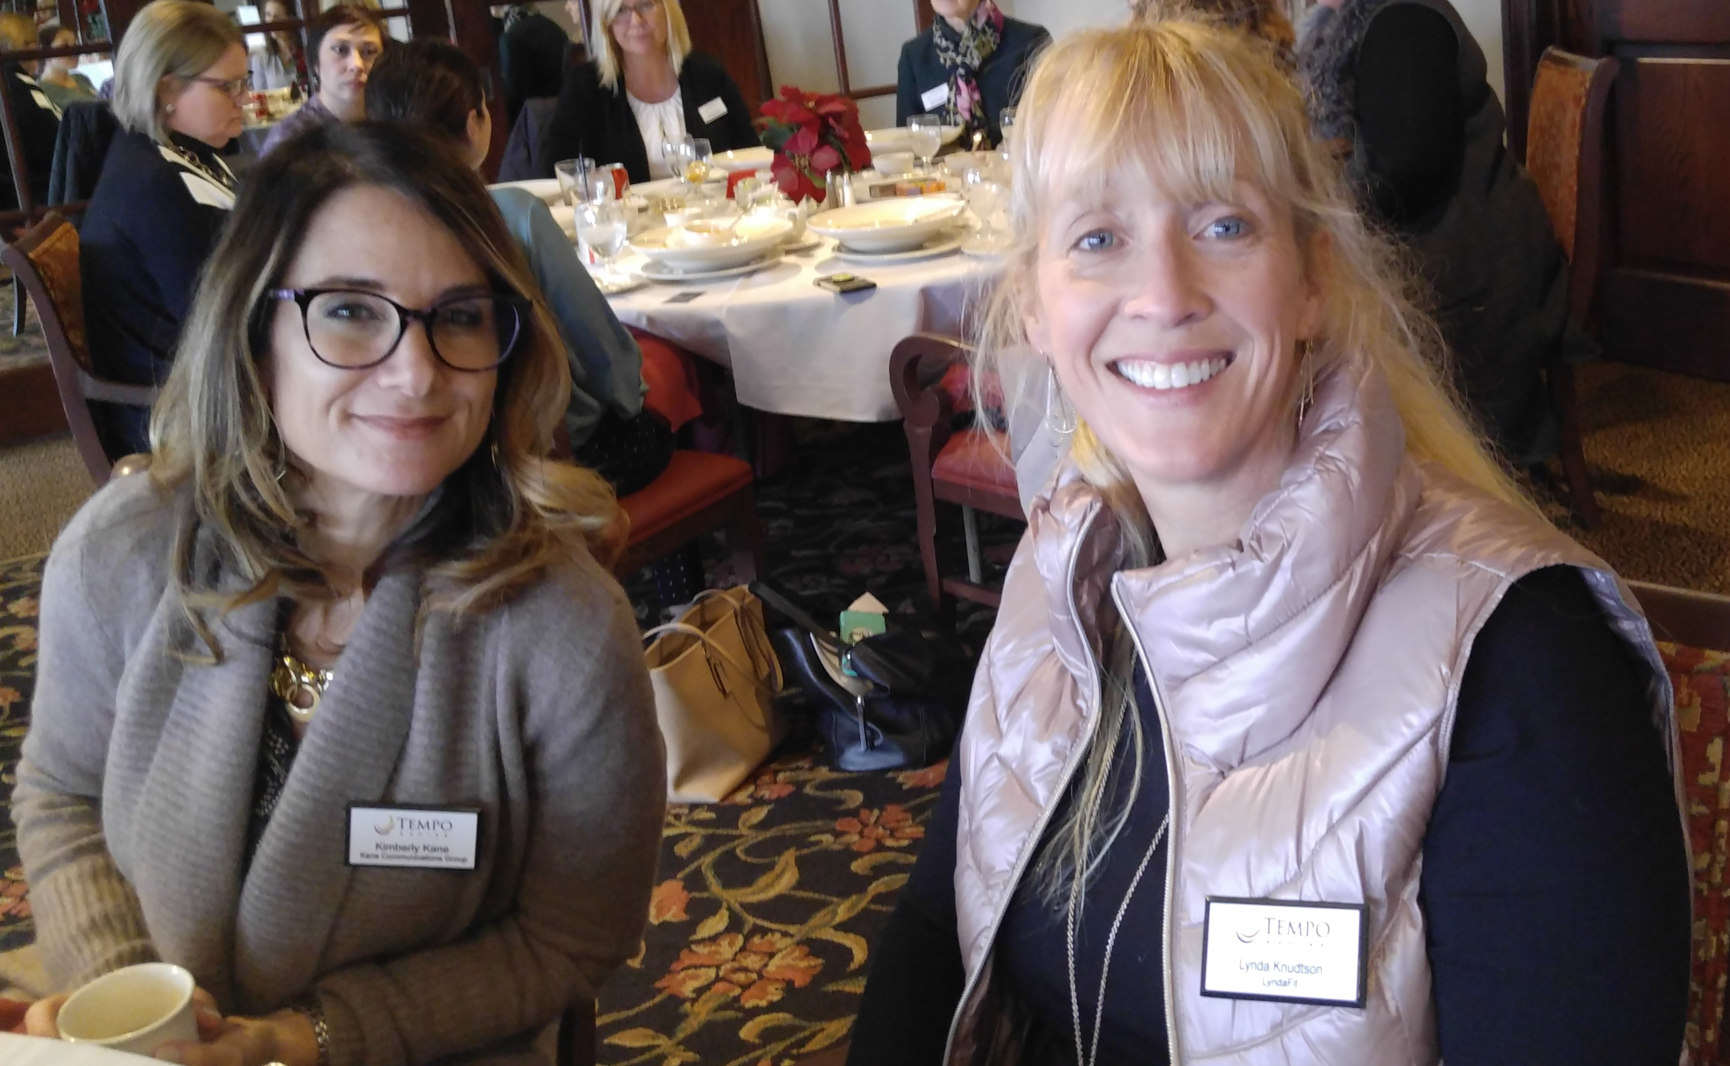
Send us your announcements, awards and recognitions!
Please send us your event information, updates, personal awards and recognitions so we can share! Send to: temporacine@gmail.com.

Connect with TEMPO Racine online!
Visit our website to view information about upcoming events
and recent news. Members, you can also log in to the site to view and edit your profile, view your RSVP submissions, view invoice history, search the member directory, and communicate with other members.

We also have a Facebook page and a new LinkedIn page
where we post event information, so make sure to follow us!

We need your help!
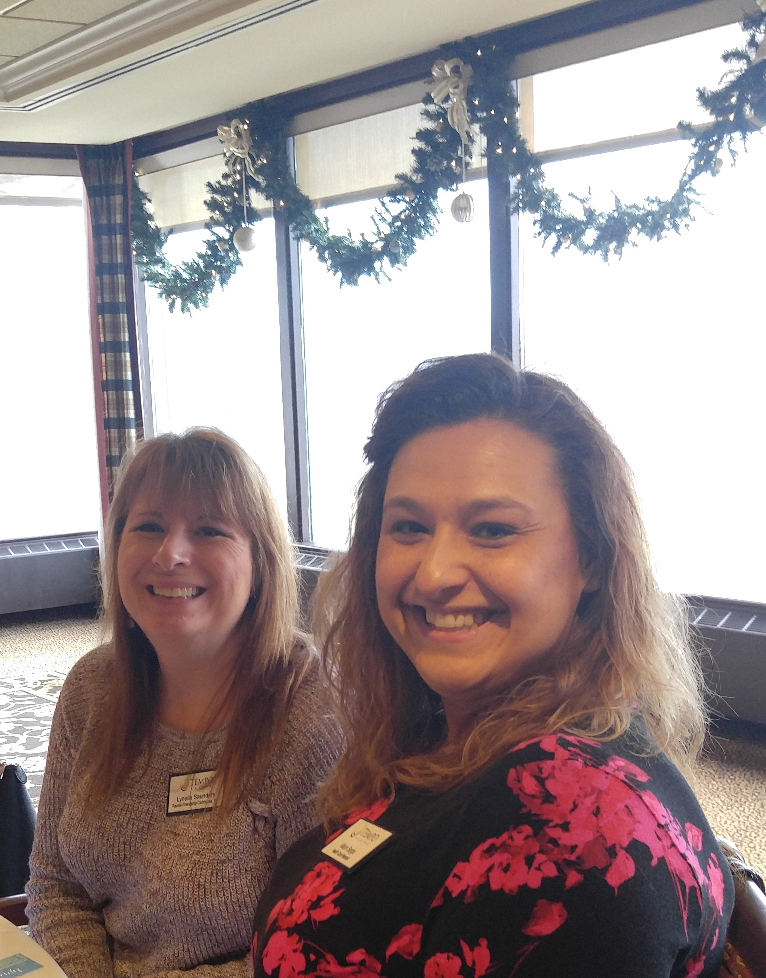
As a courtesy to our venue staff, we ask that you please RSVP to each program in a timely fashion, just as you would for any professional meeting: no later than the Monday preceding the program. The staff relies on a monthly RSVP count to plan for the number of meals and types of dietary accommodations to prepare. Last-minute RSVPs put them under unnecessary pressure to produce a fresh meal as quickly as possible.
We ask you to keep in mind that we are a non-profit with a strict budget. We estimate that last year we paid for approximately $1,440 in uneaten meals! That is enough savings for us to host another nice event like our July picnic! If you realize that you have a conflict and cannot attend, please communicate with us to cancel your RSVP as soon as possible. We deeply appreciate your sensitivity to this and in making improvements where we can. Thank you!
How did we do?
Please complete our one-minute
December Program Survey, and
January Program Survey.
If you didn't attend, the survey simply asks you to select the factor(s) that hindered your attendance. Everyone then has a chance to suggest program and special event ideas. We value your feedback!

TEMPO Milwaukee Programs & Events
Tempo milwaukee calendar

TEMPO Racine members have the benefit of being able to attend TEMPO Milwaukee events at their guest fee rate without an invitation. Simply contact us at temporacine@gmail.com if you are interested in attending a particular event, and we'll handle the rest.

Nominate your guests for membership with TEMPO Racine!
We are eager to welcome new members who are passionate about leadership, professional development, and uplifting their communities! Do you have someone in mind? Nominate them here!

We urge every member to visit our FAQ page (Become a Member tab on the website) to review the details of membership and the application process. Be sure to share this page with your guests and potential nominees, as well! If you or they have any questions, please reply to this email or contact a board member.

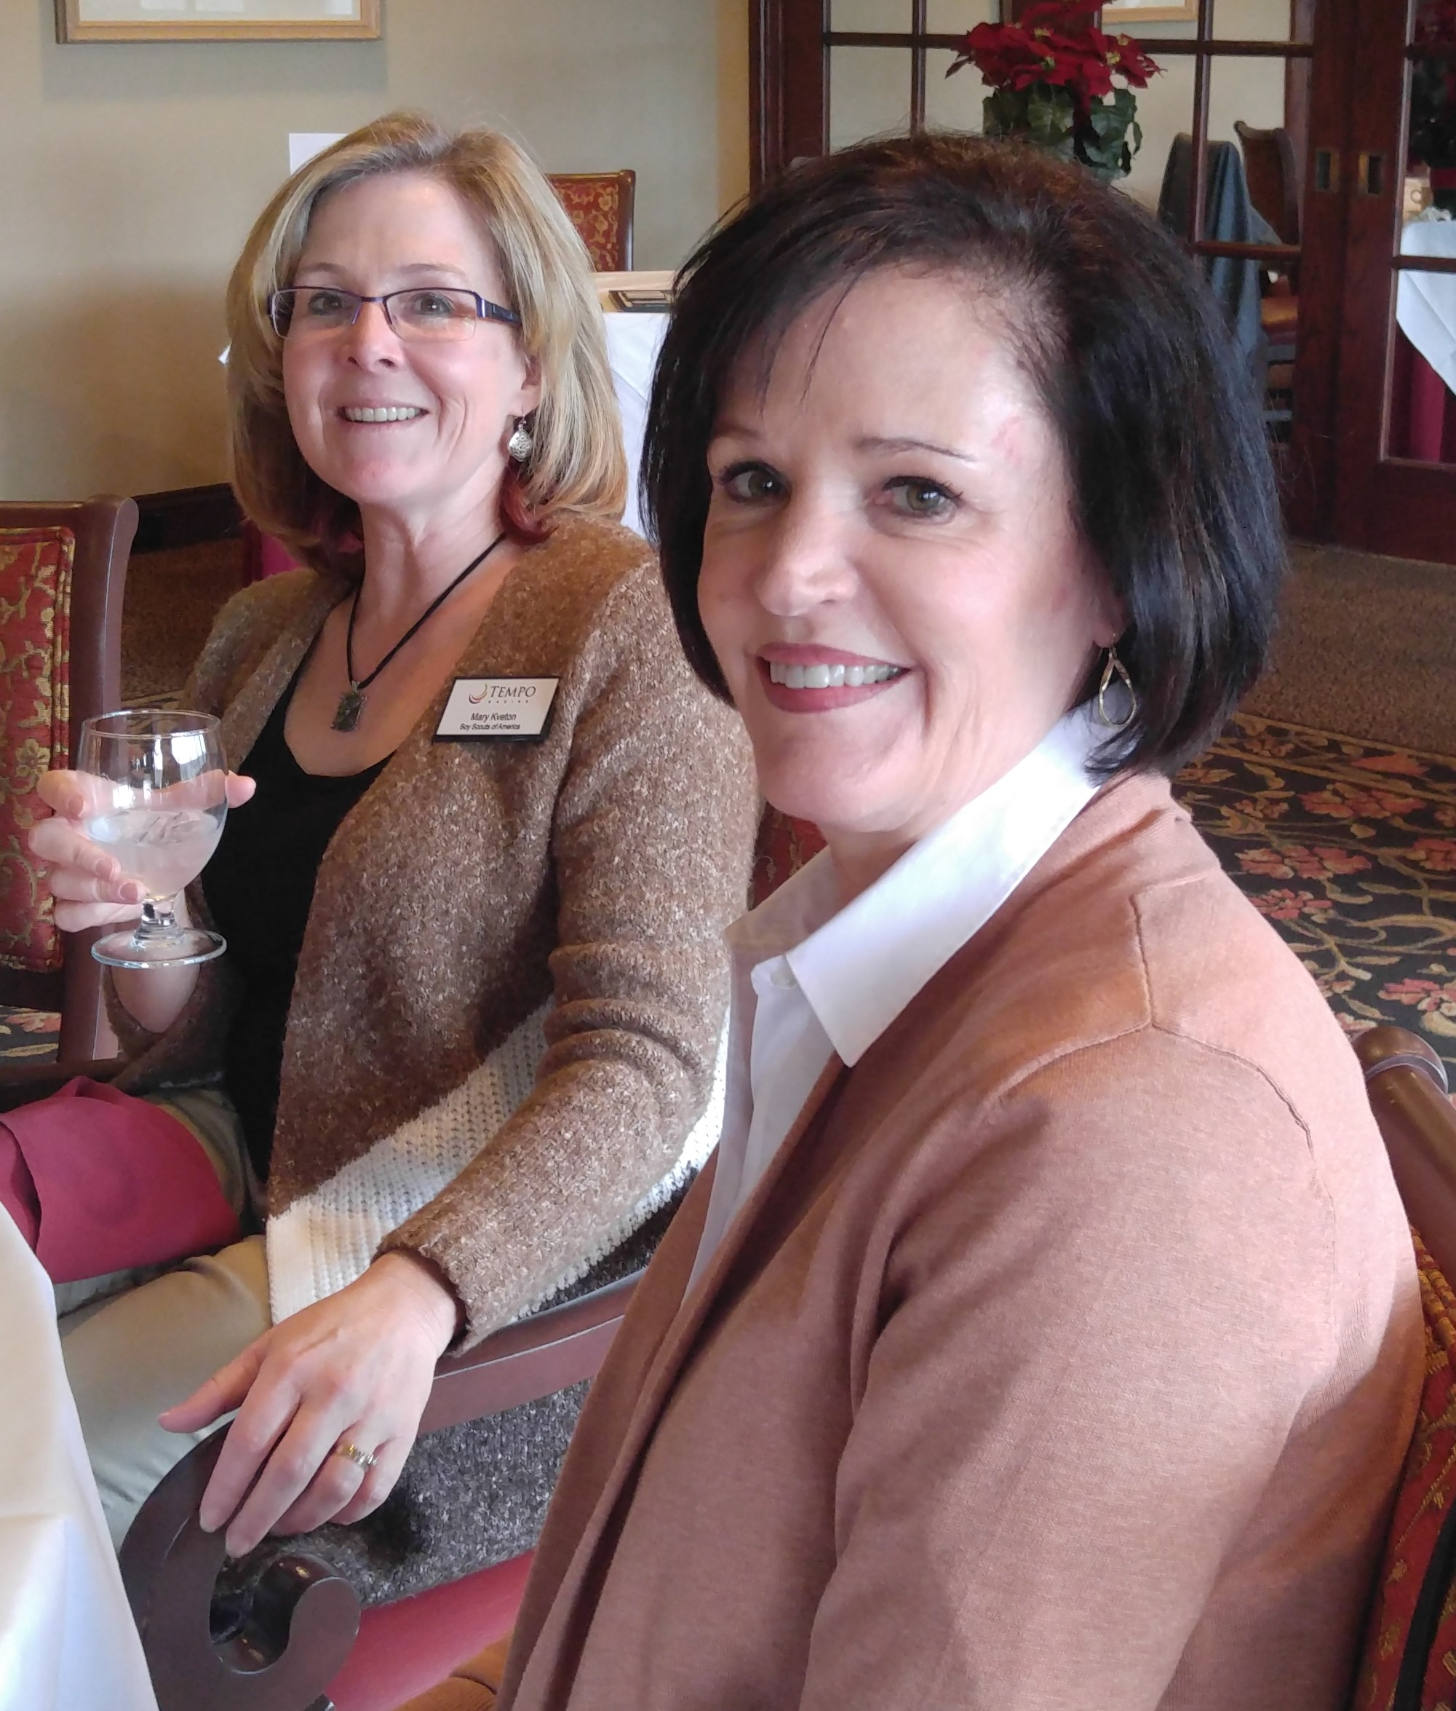

We proudly thank our generous sponsors!

| www.temporacine.org | temporacine@gmail.com

